***PRACTICAL 2A: NAND GATE REPRESENTATION***

*Ronak Mehta (MHTRON001)*

**Plagiarism Declaration**

1. I know that plagiarism is wrong. Plagiarism is to use another’s work and pretend that it is one’s own.

2. I have used the IEEE convention for citation and referencing. Each contribution to, and quotation in, this practical report from the work(s) of other people has been attributed and has been cited and referenced.

3. This practical report (including circuit diagrams and code) is my own work.

4. I have not allowed, and will not allow, anyone to copy my work with the intention of passing it off as their own work.

5. I acknowledge that copying someone else’s code, schematics or report, or part of it, is wrong, and declare that this is my own work.

18-04-2018

Signature Date

**Solutions**

a) Y = (A . B . C . D) + (Ā . B) + (A . C) + (!B . D) + (Ā . !C . D)

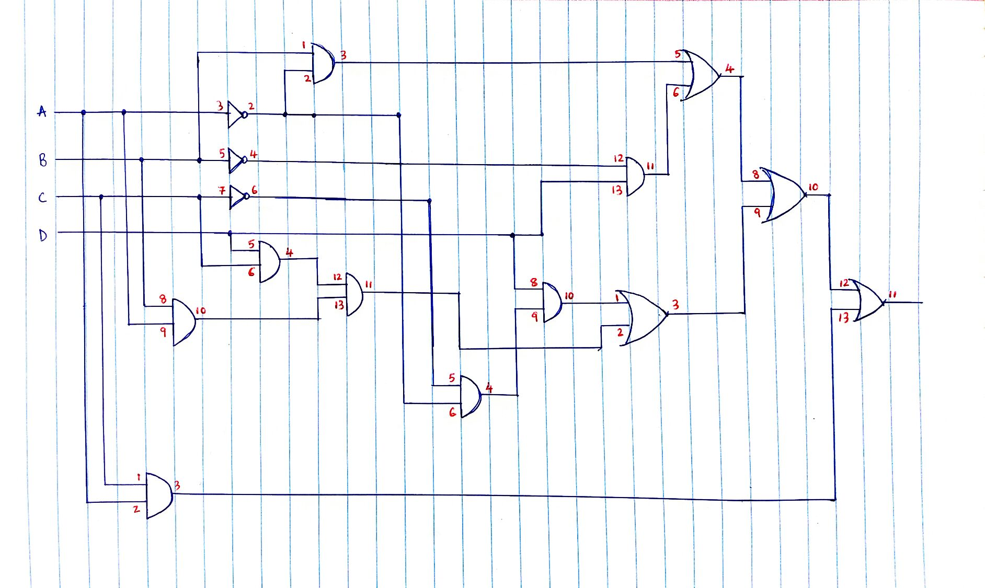

b) It will need Four 4000 series logic chips.

* 1 Quad 2-input OR-gate (4071)
* 2 Quad 2-input AND-gate (4081)
* 1 Hex Buffer Inverter (4049)

c)

|  |  |  |  |  |  |  |  |  |  |
| --- | --- | --- | --- | --- | --- | --- | --- | --- | --- |
| **A** | **B** | **C** | **D** | **(A.B.C.D)** | **(Ā.B)** | **(A.C)** | **(!B.D)** | **(Ā.!C.D)** | **Y** |
| 0 | 0 | 0 | 0 | 0 | 0 | 0 | 0 | 0 | 0 |
| 0 | 0 | 0 | 1 | 0 | 0 | 0 | 1 | 1 | 1 |
| 0 | 0 | 1 | 0 | 0 | 0 | 0 | 0 | 0 | 0 |
| 0 | 0 | 1 | 1 | 0 | 0 | 0 | 1 | 0 | 1 |
| 0 | 1 | 0 | 0 | 0 | 1 | 0 | 0 | 0 | 1 |
| 0 | 1 | 0 | 1 | 0 | 1 | 0 | 0 | 1 | 1 |
| 0 | 1 | 1 | 0 | 0 | 1 | 0 | 0 | 0 | 1 |
| 0 | 1 | 1 | 1 | 0 | 1 | 0 | 0 | 0 | 1 |
| 1 | 0 | 0 | 0 | 0 | 0 | 0 | 0 | 0 | 0 |
| 1 | 0 | 0 | 1 | 0 | 0 | 0 | 1 | 0 | 1 |
| 1 | 0 | 1 | 0 | 0 | 0 | 1 | 0 | 0 | 1 |
| 1 | 0 | 1 | 1 | 0 | 0 | 1 | 1 | 0 | 1 |
| 1 | 1 | 0 | 0 | 0 | 0 | 0 | 0 | 0 | 0 |
| 1 | 1 | 0 | 1 | 0 | 0 | 0 | 0 | 0 | 0 |
| 1 | 1 | 1 | 0 | 0 | 0 | 1 | 0 | 0 | 1 |
| 1 | 1 | 1 | 1 | 1 | 0 | 1 | 0 | 0 | 1 |

d) **Sum of minterms = Sum of Products**

Y = (!A . !B . !C . D) **+** (!A . !B . C. D) **+** (!A . B . !C . !D) **+** (!A . B . !C . D) **+** (!A . B . C . !D) **+** (!A . B . C . D) **+**

(A . !B . !C . D) **+** (A . !B . C . !D) **+** (A . !B . C . D) **+** (A . B . C . !D) **+** (A . B . C . D)

e) **Product of maxterms = Product of Sum**

Y = (A + B + C + D) **.** (A + B + !C + D) **.** (!A + B + C +D) **.** (!A + !B + C + D) **.** (!A + !B + C + !D)

f)

**KARNAUGH MAP**

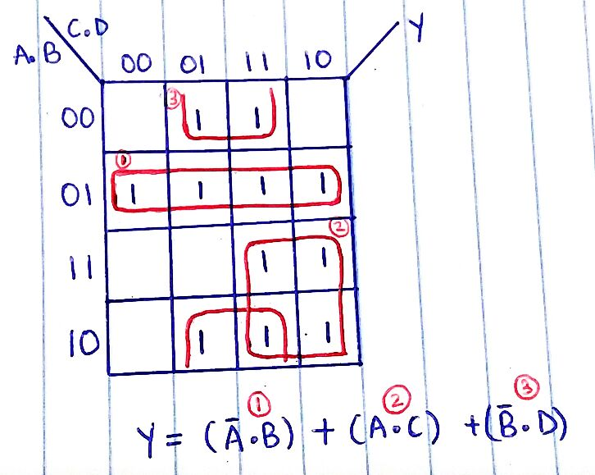

g) **Y = (!A . B) + (A . C) + (!B . D)**

Y = !( !((!A . B) + (A . C) + (!B . D)) )

Y = !( !((!A . B)) . !((A . C)) . !((!B . D)) )

Y = !( !(!(A.A) . B) . !(A . C) . !(!(B.B) . D) ) //Simplified Version

For more complex but detailed circuit; join two of the expressions with a NAND gate and then NAND

the output with itself

Y = !( !(!(A.A) . B) . !(!(B.B) . D) . !(A . C) )

Y = !( !( !(!(A.A).B) . !(!(B.B).D) ) . !(A . C) )

Y = !( !( !( !(!(A.A).B) . !(!(B.B).D) ) . !( !(!(A.A).B) . !(!(B.B).D) ) ) . !(A . C) )

h)

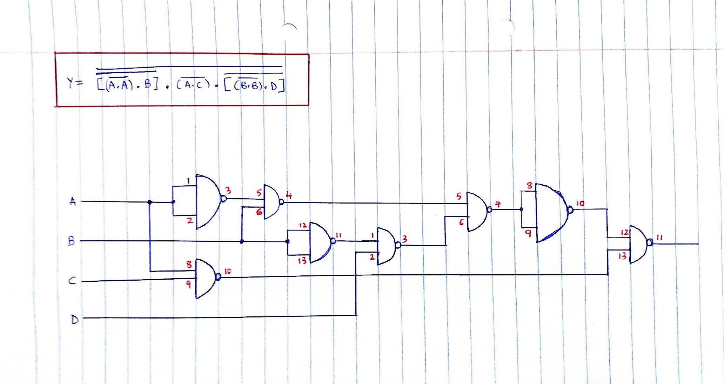

j)

Y = !( !(!(A.A) . B) . !(A . C) . !(!(B.B) . D) )

|  |  |  |  |  |  |  |  |  |  |  |
| --- | --- | --- | --- | --- | --- | --- | --- | --- | --- | --- |
| **A** | **B** | **C** | **D** | **!(A.A)** | **!( !(A.A) .B)** | **!(A.C)** | **!(B.B)** | **!( !(B.B) .D)** | **Y** | **VERIFIED** |
| 0 | 0 | 0 | 0 | 1 | 1 | 1 | 1 | 1 | 0 | 0 |
| 0 | 0 | 0 | 1 | 1 | 1 | 1 | 1 | 0 | 1 | 1 |
| 0 | 0 | 1 | 0 | 1 | 1 | 1 | 1 | 1 | 0 | 0 |
| 0 | 0 | 1 | 1 | 1 | 1 | 1 | 1 | 0 | 1 | 1 |
| 0 | 1 | 0 | 0 | 1 | 0 | 1 | 0 | 1 | 1 | 1 |
| 0 | 1 | 0 | 1 | 1 | 0 | 1 | 0 | 1 | 1 | 1 |
| 0 | 1 | 1 | 0 | 1 | 0 | 1 | 0 | 1 | 1 | 1 |
| 0 | 1 | 1 | 1 | 1 | 0 | 1 | 0 | 1 | 1 | 1 |
| 1 | 0 | 0 | 0 | 0 | 1 | 1 | 1 | 1 | 0 | 0 |
| 1 | 0 | 0 | 1 | 0 | 1 | 1 | 1 | 0 | 1 | 1 |
| 1 | 0 | 1 | 0 | 0 | 1 | 0 | 1 | 1 | 1 | 1 |
| 1 | 0 | 1 | 1 | 0 | 1 | 0 | 1 | 0 | 1 | 1 |
| 1 | 1 | 0 | 0 | 0 | 1 | 1 | 0 | 1 | 0 | 0 |
| 1 | 1 | 0 | 1 | 0 | 1 | 1 | 0 | 1 | 0 | 0 |
| 1 | 1 | 1 | 0 | 0 | 1 | 0 | 0 | 1 | 1 | 1 |
| 1 | 1 | 1 | 1 | 0 | 1 | 0 | 0 | 1 | 1 | 1 |